Lab assignment no 4

Name – Abhijit Gawai

Roll no – 18 (Batch 1)

Gr no – 11810895

Problem Statement -

|  |
| --- |
| Execute ‘SELECT’ queries using various operators. Also make use of order by, group by, having clause, aggregate functions,view and set operators and join operation(equijoin, non equijoin, self join And outer join.) |
| . Create views, indices, and sequence on your database schema involving two Or more tables. Use SQL single row functions: date, time, string functions etc |

**TOPIC – RFID Based shopping Mall**

Select :SELECT * FROM Customer5;

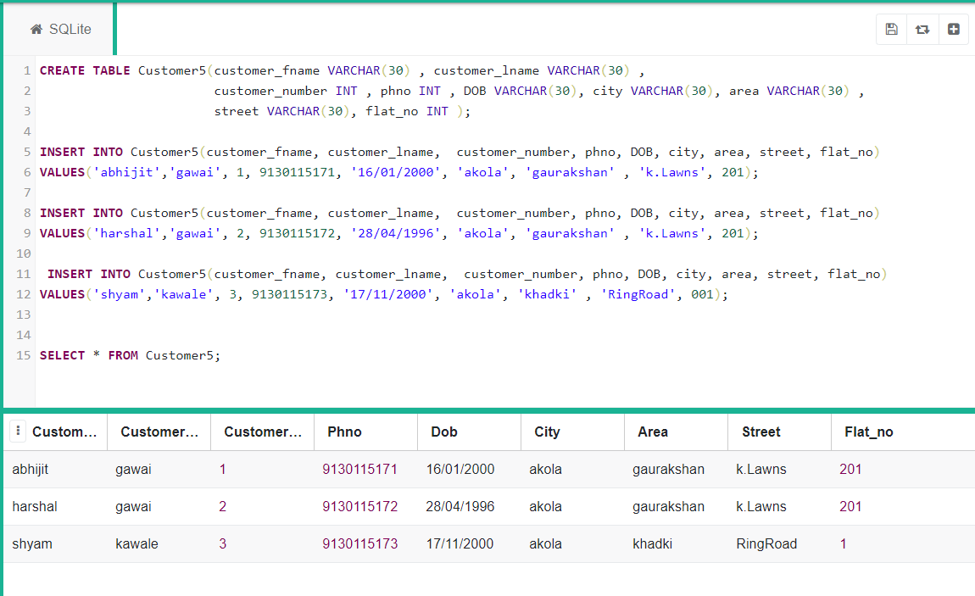

AND: select * from Customer5 where City='akola' AND Phno>9130115171;

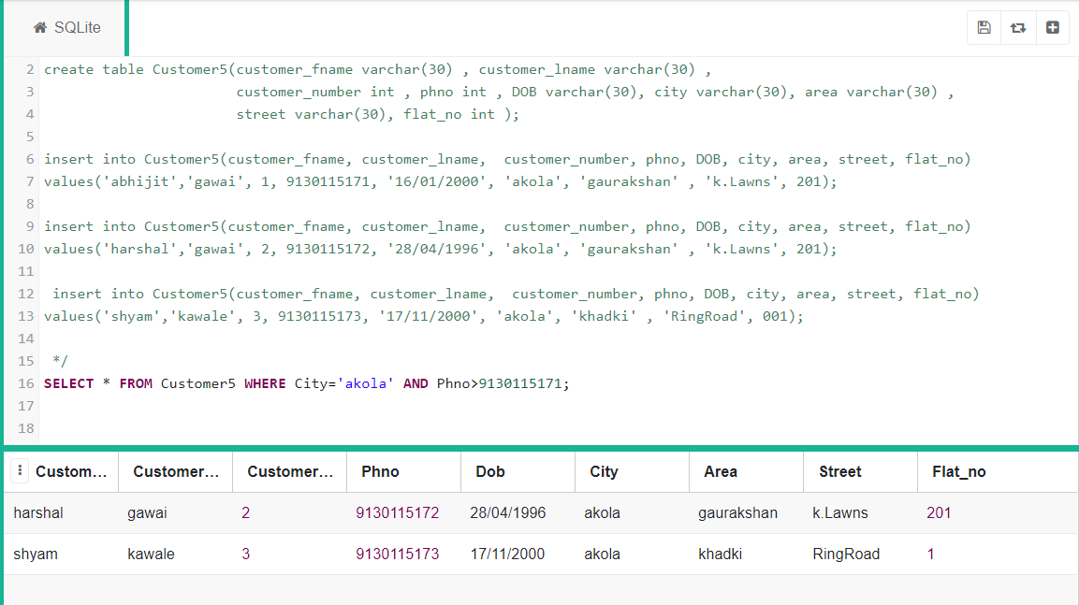

OR: select * from Customer5 where Customer_fname='abhijit' OR Customer_lname='gawai'; 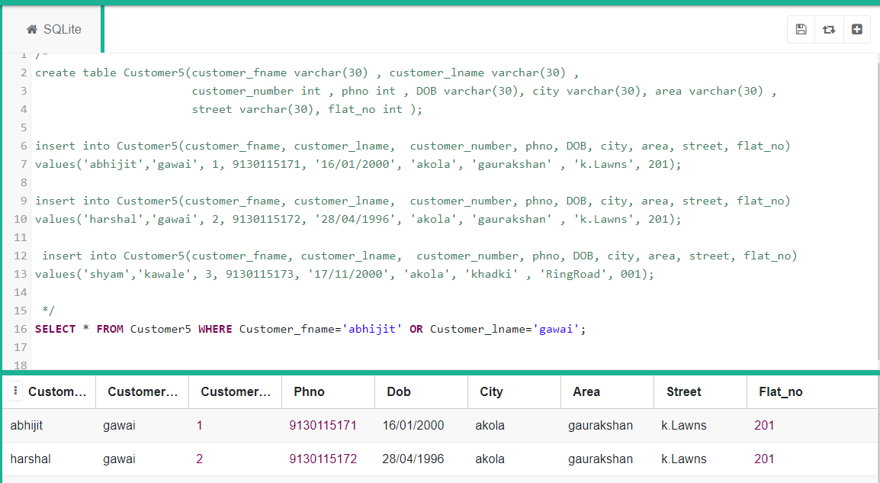

Data Inserted here

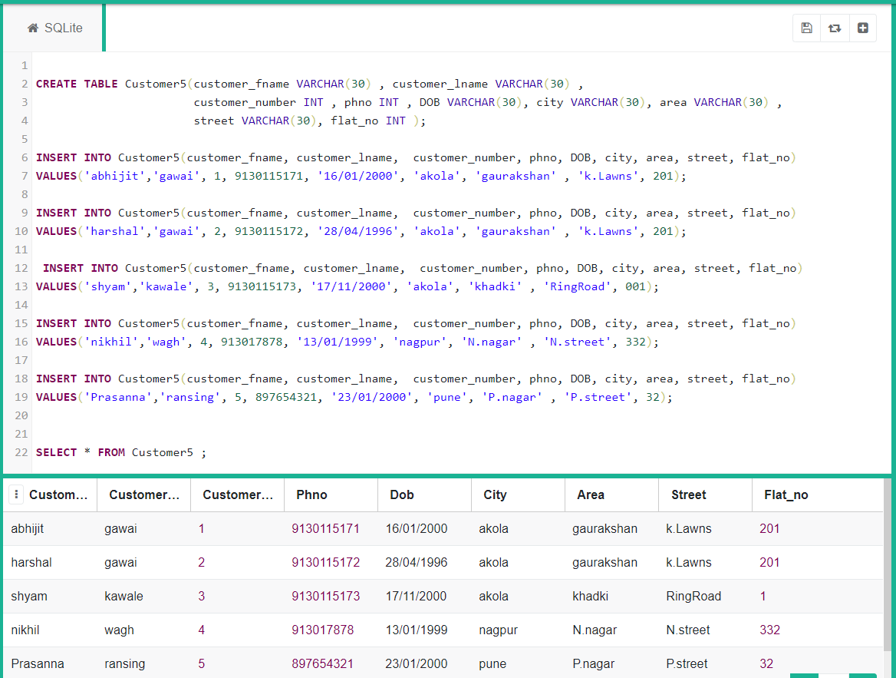

NOT: select * from Customer5 where not Street='k.Lawns';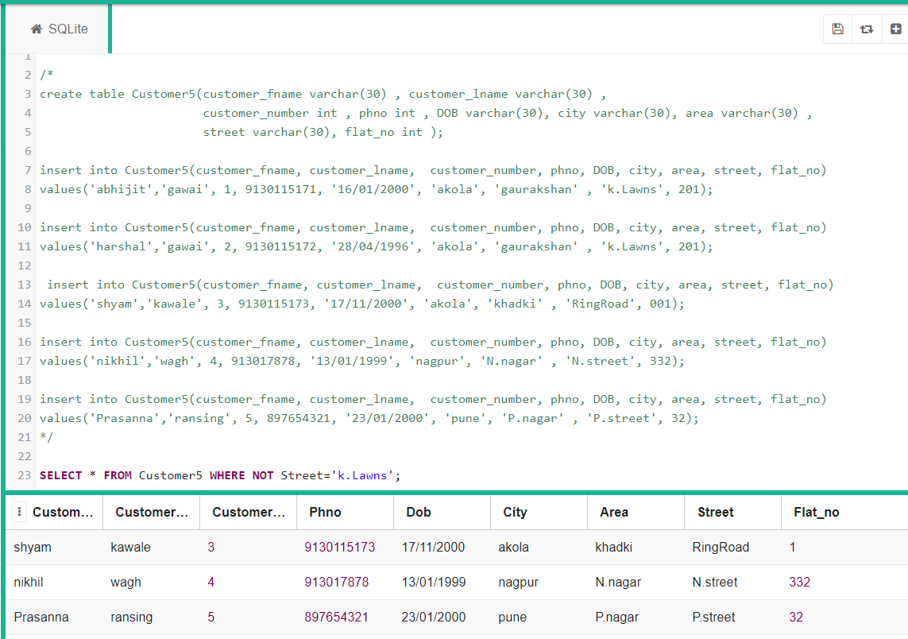

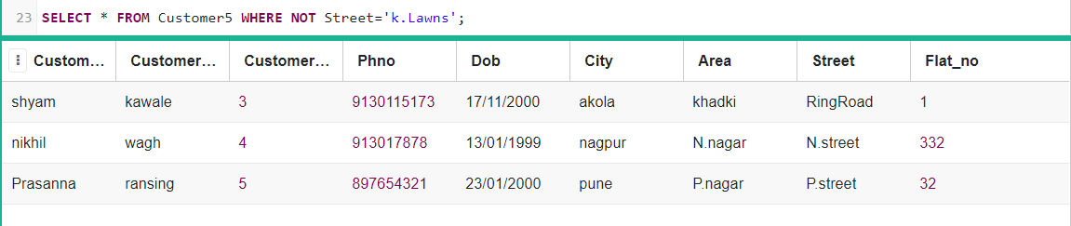

< : select * from Customer5 where flat_no<100;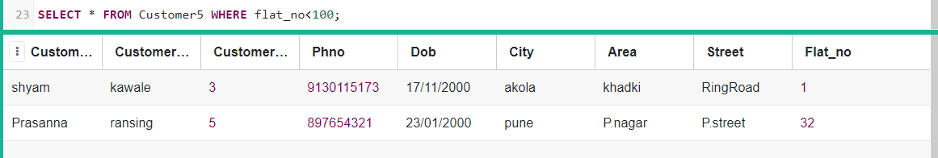

Logical

<= : select * from Customer5 where flat_no<=201;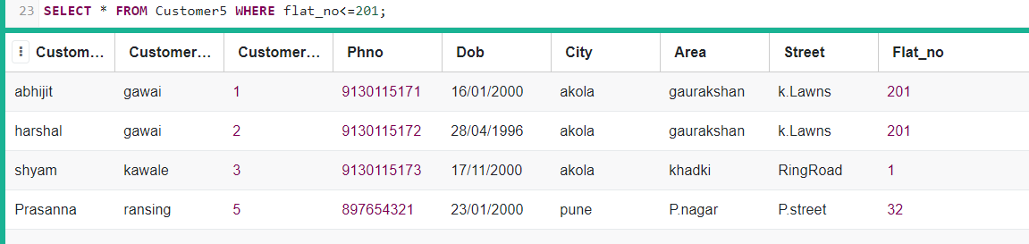

!= : select * from Customer5 where flat_no!=201;

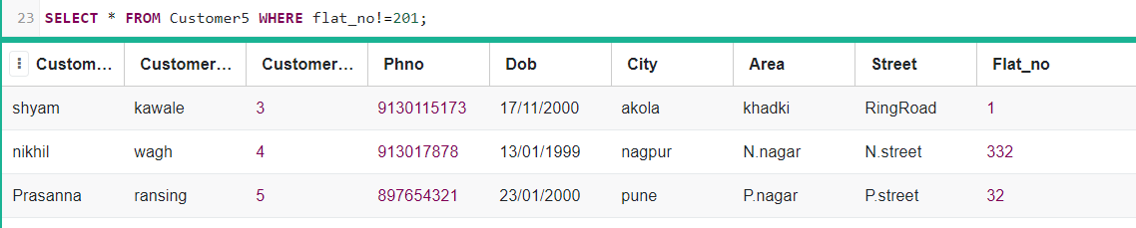

Like: select * from Customer5 where phno like '9130%';

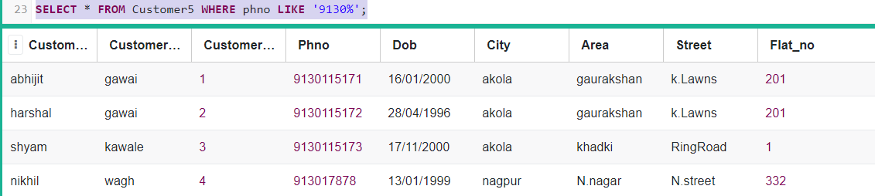

Not like : select * from Customer5 where phno not like '9130%';

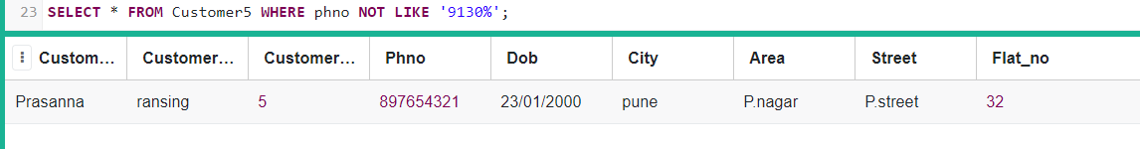

IN : select * from Customer5 where city in ('akola','pune');

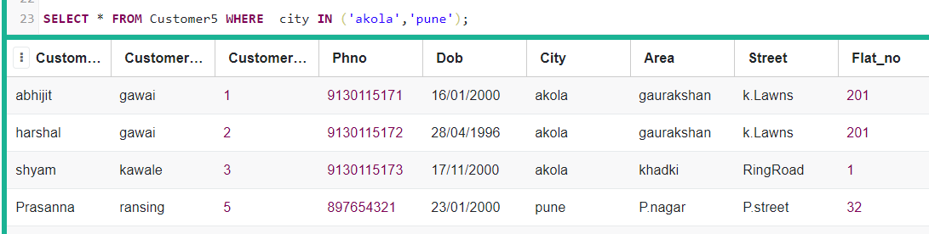

NOT IN : select * from Customer5 where city not in ('akola','pune');

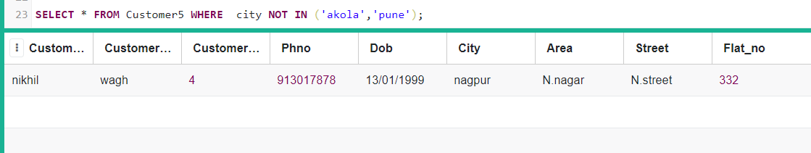

Null : select * from Customer5 where phno is null;



Not null : select * from Customer5 where phno is NOT null;

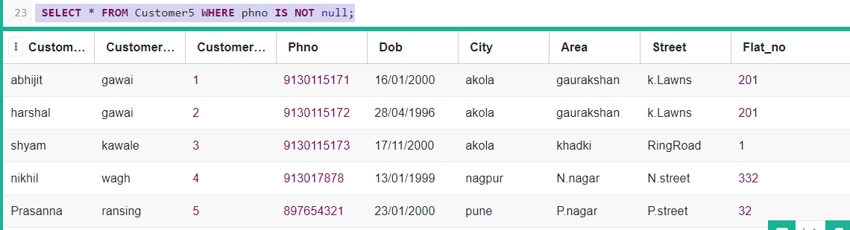

Between : select customer_fname from Customer5 where customer_number between 2 and 4;

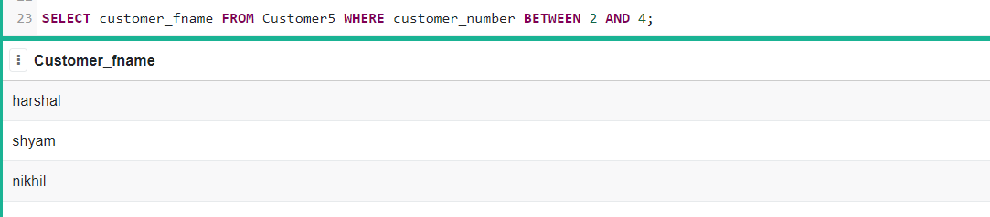

AGGREGATE

Max : select max(flat_no) from Customer5;

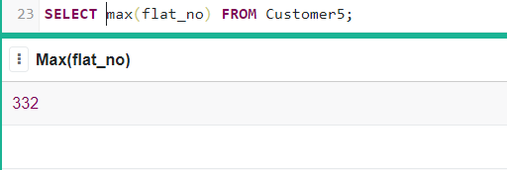

Min : select min(flat_no) from Customer5;

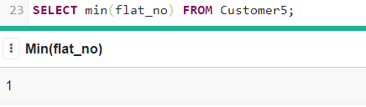

Group By : SELECT area , count(area) FROM Customer5 GROUP BY area;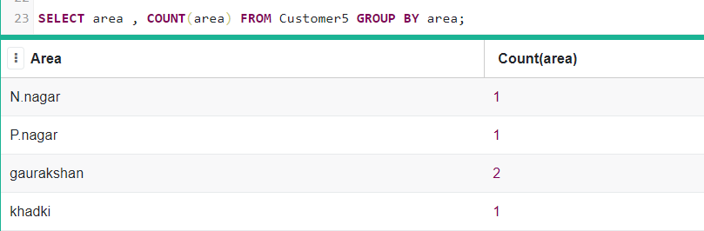

Order by

Ascending order: select * from Customer5 order by flat_no;

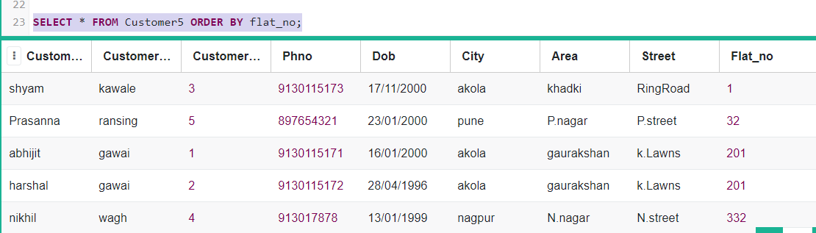

Desending: select * from Customer5 order by flat_no desc;

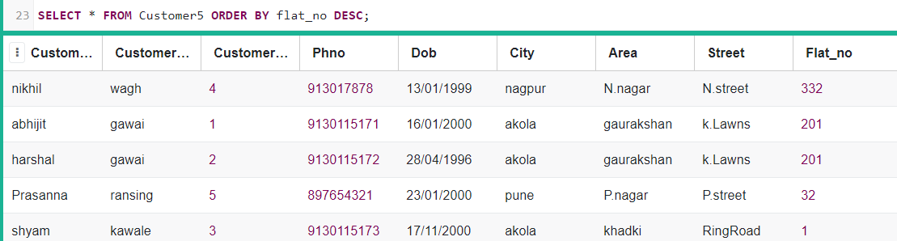

New data added

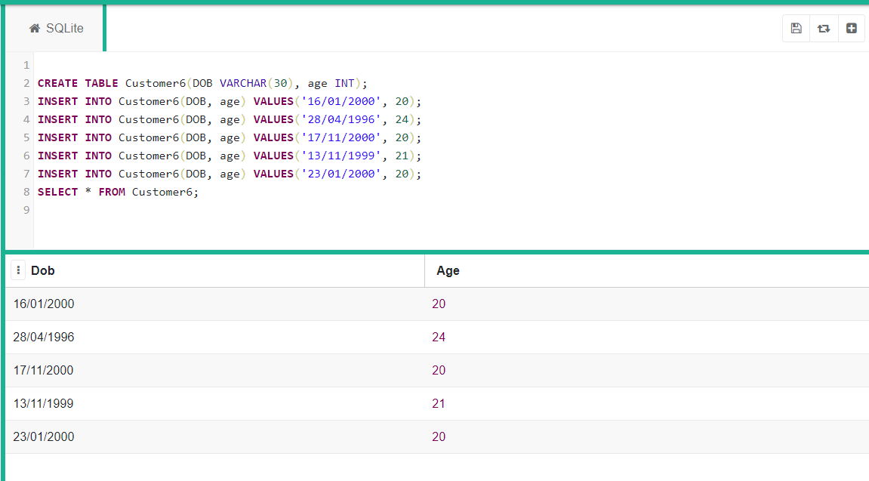

Equi join: select c5.customer_fname, c5.dob, c6.age from Customer5 c5, Customer6 c6 where c5.dob=c6.dob;

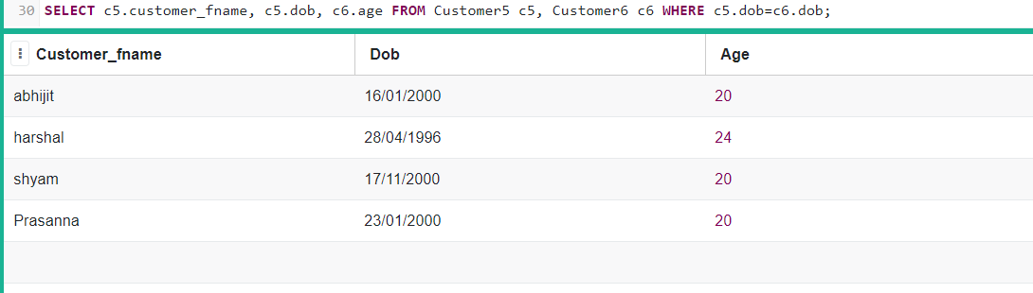

Non equi join: select c5.customer_fname, c5.dob, c6.age from Customer5 c5, Customer6 c6 where c5.dob in ('16/01/2000','28/04/1996');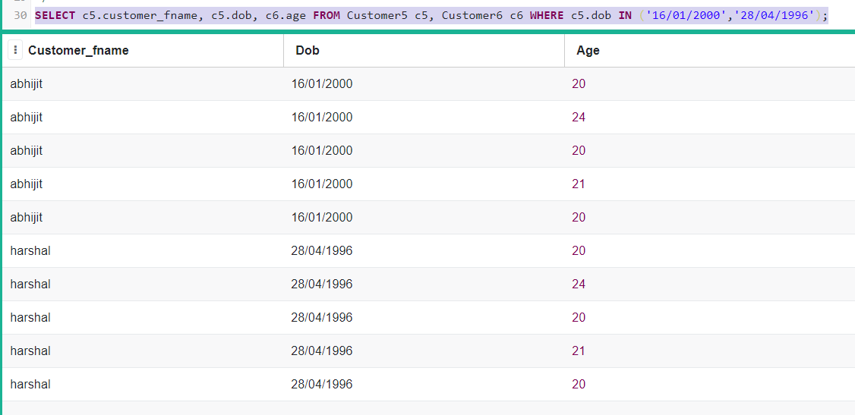

Right outer join : select * from Customer5 right outer join Customer6 on Customer5.dob = Customer6.dob;

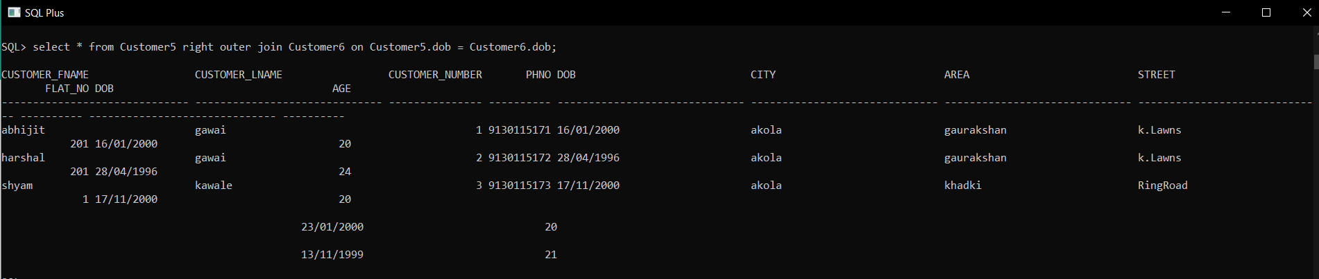

Left outer join: select * from Customer5 LEFT outer join Customer6 on Customer5.dob = Customer6.dob;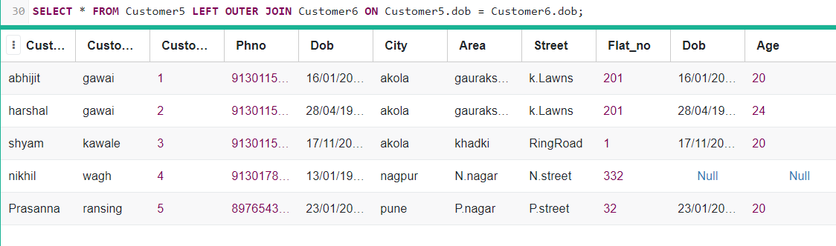

Full outer join: select * from Customer5 right outer join Customer6 on Customer5.dob = Customer6.dob

union

select * from Customer5 right outer join Customer6 on Customer5.dob = Customer6.dob;

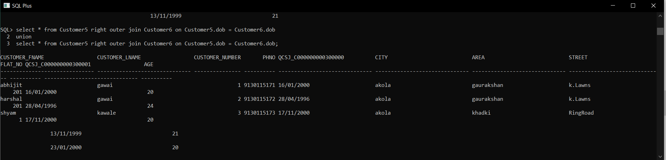

Self join: select c5.customer_fname, c6.dob from Customer5 c5, Customer6 c6 where c5.customer_fname=c6.dob;

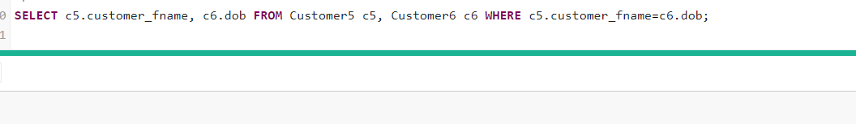

index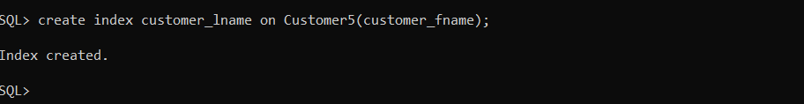

Single row function

sysdate

SELECT Customer_fname, (sysdate - flat_no) Customer_fname FROM Customer5;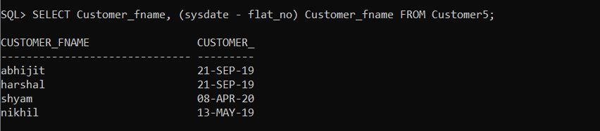

LPAD and RPAD

SELECT RPAD(customer_fname,10,'_')||LPAD (customer_lname,15,'_') FROM Customer5;

